Topic 6.15: Generating All Subsets of a Set
Question
You are tasked with designing an efficient coding method to generate all subsets of a given set S containing n elements. Each subset should be outputted in lexicographical order. Return a list of lists where each inner list is a subset of the given set. Additionally, explain how your coding handles duplicate elements in S.
Example:
For A = [1, 2, 3] the subsets are:
[], [1], [2], [3], [1, 2], [1, 3], [2, 3], [1, 2, 3]
Aim
To implement an algorithm that generates all subsets of a given set in lexicographical order and analyze its behavior in the presence of duplicate elements.
Algorithm
- Sort the input set to ensure lexicographical ordering of subsets.
- Use backtracking:
  - Start with an empty subset.
  - At each step, choose whether to include the current element.
  - Recurse to the next element.
  - Append each generated subset to the result.
- To handle duplicates:
  - If the set contains duplicate elements, skip duplicate branches to avoid generating identical subsets.
- Return the final list of subsets.
Output
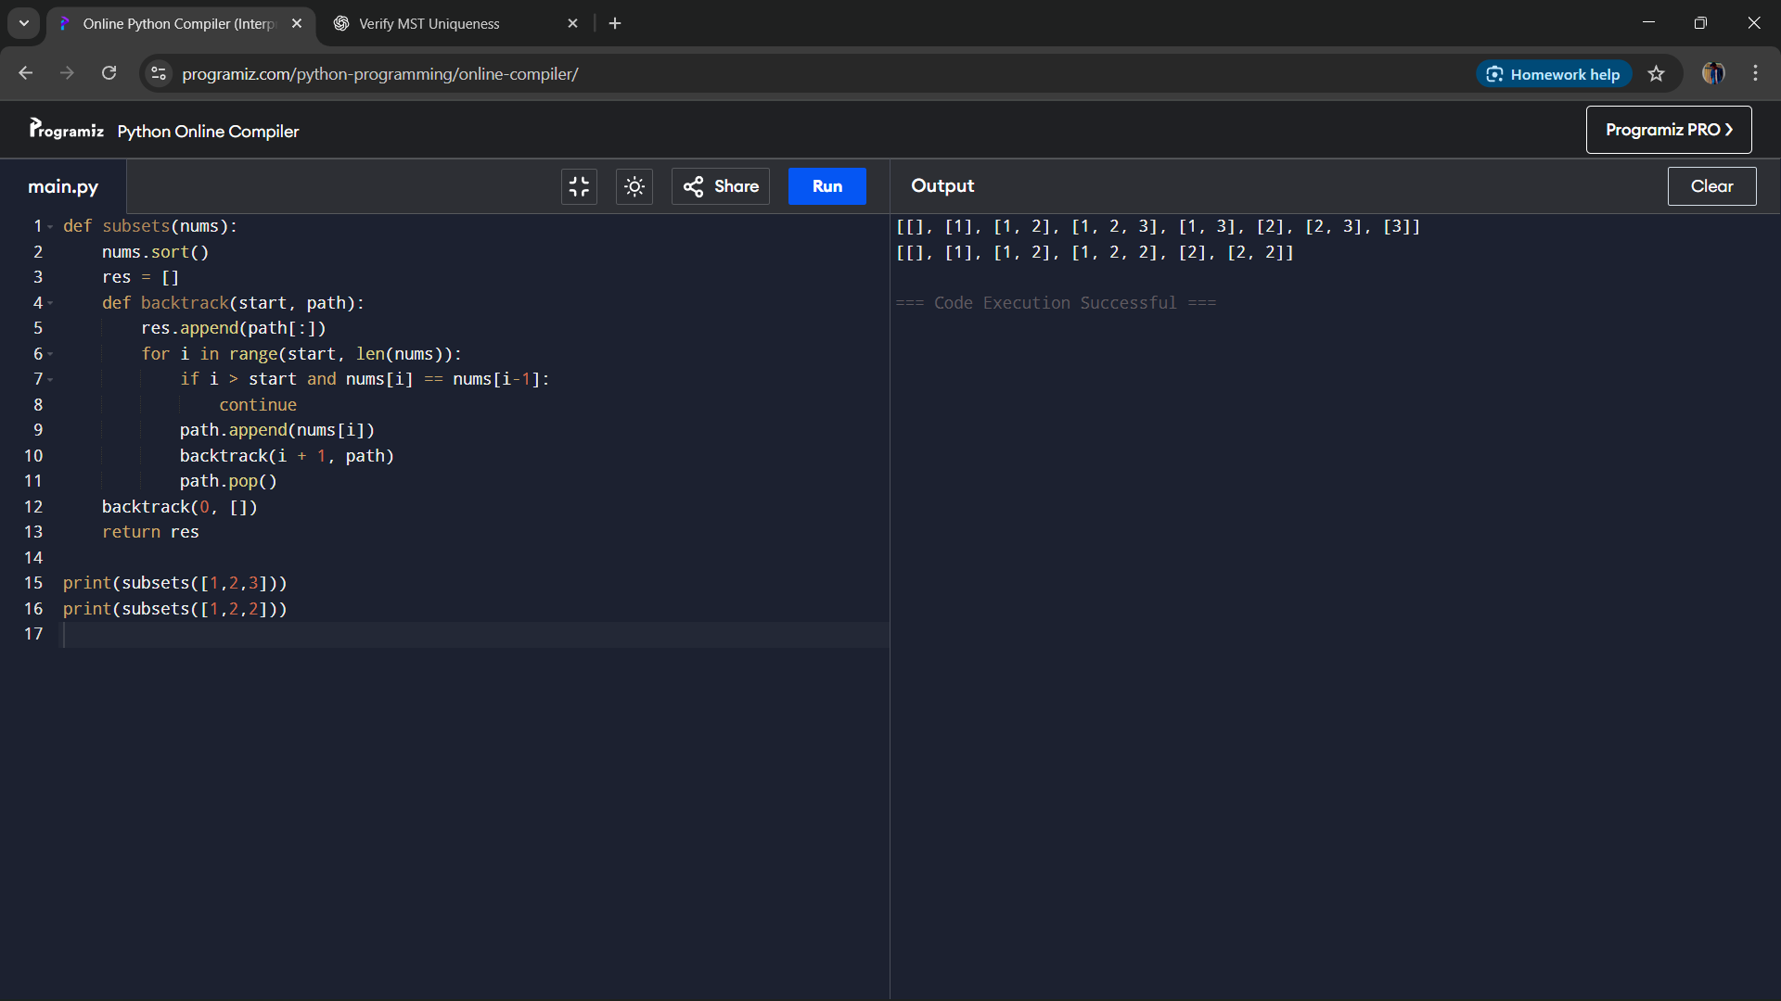
Result
The algorithm generates all subsets of the given set in lexicographical order. It can handle duplicates by applying checks to skip repeated elements.
Performance Analysis
- Time Complexity: O(2^n), since each element can either be included or excluded.
- Space Complexity: O(2^n) for storing all subsets and O(n) for recursion depth.

